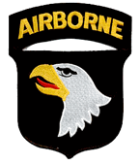
ALPHA AVENGERS OF VIETNAM ASSOCIATION
2nd/501st Infantry 101st Airborne Division
2020 AAVA REUNION - BOISE, IDAHO

Greetings Alpha Avengers Brothers and Sisters,

I want to take this opportunity to wish you all a Merry Christmas and
Happy New Year! Our reunion in Boise, Idaho is coming up fast and
we hope you will be able to join us there! The reunion is being held at
the Riverside Hotel from June 1-3, 2020, at the room rate of $108.00 per night but the hotel is offering the same discounted rate for three days before and three days after the reunion. Sherry and I will be making a vacation out of it and coming in early and staying a few days after, so we can see all the area has to offer. If you desire to come in early and or stay after the reunion, be sure to make your reservations with the hotel as early as possible. We have a guaranteed block of rooms for the reunion dates but the dates before and after are on an availability basis only. SO I AM ENCOURAGING YOU TO MAKE YOUR RESERVATIONS NOW (your credit card will not be charged prior to the reunion)

While visiting Boise last summer, to prepare for the reunion, we decided that we would not have one big tour but allow members to choose from the numerous activities available in the area. We found the hotel concierge helpful in setting up and suggesting outings and we will be providing a list of places to consider to visit for your use when you arrive at the reunion. The hotel provides, as part of your hotel rate, a wonderful breakfast buffet and there are other restaurants on site, as well as, within walking distance of the hotel for your other meal choices throughout the day. In addition, Downtown Boise also offers many options to explore and places to dine. The hotel shuttle will take you downtown and pick you up but their priority is to provide airport shuttle transportation. Uber and Lyft are available options if you require immediate transportation.

We will again be honoring the family of one of our own, with the Some Gave All Award, at our banquet on the last night of the reunion. I personally feel I owe every day to those who laid down their lives to protect and defend those of us that were able to come home. You can check our website for the list of recipients and if you have suggestions for future reunions, please let us know.

I have been in touch with a number of guys who have never been to one of our reunions and I really hope that they will be able to come and rekindle some old relationships as well as forge some new ones. We have a special bond that was created during difficult and sometimes horrifying times, and it is a blessing to encourage others and be encouraged by them as we move through this stage of our lives.

As an organization our desire is to reconnect all members of A CO 2nd of the 501st Infantry 101st Airborne Division who served in Vietnam. These reunions are our way of rekindling those bonds of brotherhood. We sincerely hope to see you all in Boise on June 1, 2020.

God Bless You All,
Ken Snyder, President
Hi everyone,
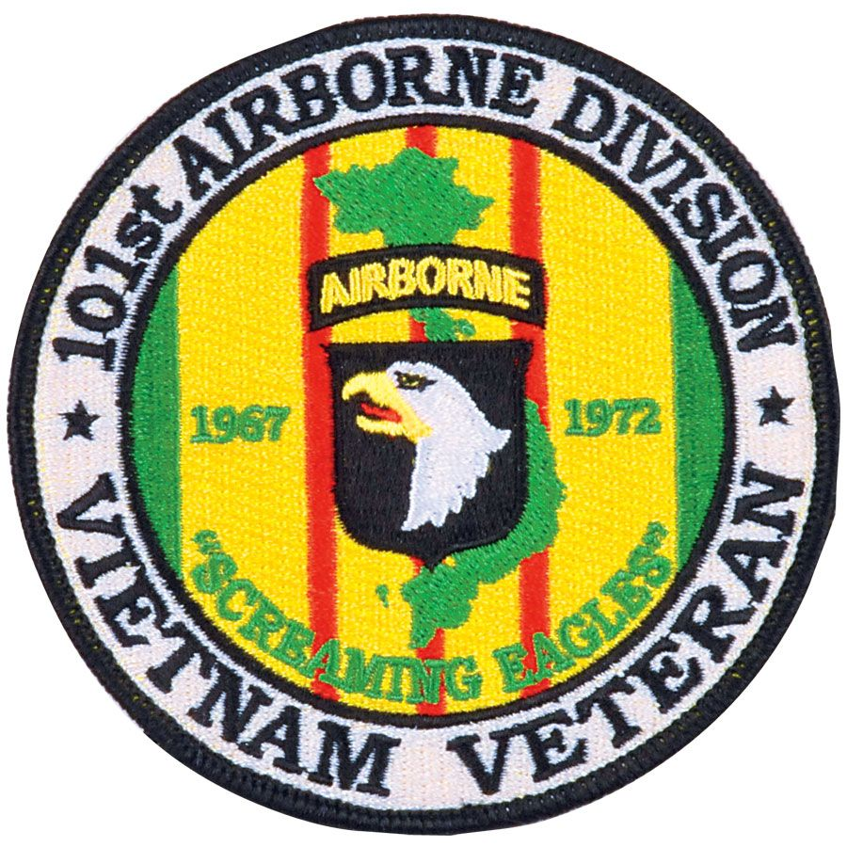
I hope everyone had an enjoyable Thanksgiving Holiday and at some point, during the day, took a moment to pause and reflect on what it meant to each of us to be far from home during the holidays so many years ago. Let us always remember to thank our service men & women for putting their personal lives on hold while they are keeping us safe and secure back home in the USA.

The primary reason for this note is to ask each and every member to reach out to any of their buddies who have not yet attended an Alpha Company reunion and encourage them to make the trip to Boise Idaho for what will be a memorable trip. My wife Naomi and I attended the 2018 Gettysburg reunion, which was my first and if God is willing, will not be my last! I too was unsure about attending the reunion and I had so many reservations, history has created so many stereotypes for Vietnam Vets that I really didn’t know what to expect. As soon as we entered the hotel door & registered, the greeting we received from Diane & Dennis Mangulli, Millard & Linda Sims immediately put my concerns to rest. To say we had fun is an understatement! There was so much to do that the three days flew by…toured the Gettysburg battlefield, dinner and drinks at night, discussions in the hotel hospitality room with some of the Alpha originals. roundtable discussions with General Mitchell, guys that served in Hue during Tet of “68, were on FSB Airborne and Hamburger Hill as well as some other places I hadn’t heard of. I also found that I thought I knew quite a few of the guys that were with me during my tour but in reality, I only really knew the guys that were in my Squad and a few from 3rd platoon. Yet at the end of the day, we were all brothers with the same shared experience, “Vietnam”. Hearing Doc Guy Rudawsksi’s speech prior to presenting the “Some Gave All Award”, was the highlight of the banquet! It was a memorable tribute and at the same time helped me gain insight as to how much the daily trauma affected our “MEDICS”. As Doc said, “Sometimes the best medicine is to talk about it.”

Don’t miss out and put this event off! We served with some of the finest men our country had to offer during an unpopular time to be in the military. To see & hear firsthand what these men have accomplished with their lives is remarkable, good people all of them and a credit to Alpha Company, 2nd 501st Inf, 101st Div.

As I said earlier, I didn’t know what to expect at the reunion, but my fears were unfounded. It was so easy and enjoyable to talk with everyone that at the end of the day I could truly say that for the first time in my life I actually felt like I was “Home”.

My best to all of you,
Brian Eveleth, Vice President

